# **Task2**

# **Project: Student Database Management System (PostgreSQL)**

1. **Database setup**

CREATE DATABASE

WITH

OWNER = postgres

ENCODING = 'UTF8'

LC_COLLATE = 'English_United States.1252'

LC_CTYPE = 'English_United States.1252'

TABLESPACE = pg_default

CONNECTION LIMIT = -1;

|  |  |
| --- | --- |
| a) Create student database: | b) Student table creation: |
| *CREATE DATABASE student_database*  *WITH*  *OWNER = postgres*  *ENCODING = 'UTF8'*  *LC_COLLATE = 'English_United States.1252'*  *LC_CTYPE = 'English_United States.1252'*  *TABLESPACE = pg_default*  *CONNECTION LIMIT = -1;* | *CREATE TABLE Student_table (*  *Student_id INT,*  *Stu_name VARCHAR(100),*  *Department VARCHAR(50),*  *Email_id VARCHAR(50),*  *Phone_no NUMERIC,*  *Address VARCHAR(250),*  *Date_Of_Birth DATE,*  *Gender VARCHAR(30),*  *Major VARCHAR(50),*  *GPA NUMERIC,*  *Grade VARCHAR(10)*  *);* |
|  |  |

**2) Data entry**

INSERT INTO Student_table (Student_id, Stu_name, Department, email_id, Phone_no, Address, Date_Of_Birth, Gender, Major, GPA, Grade)

VALUES

('1', 'Jayashree Ravi', 'Business', 'Jayashree@gmail.com', '9999999991', 'Delhi', '1999-04-26', 'Female', 'MBA', '8.8', 'A'),

('2', 'Nizam Khan', 'Arts and Sciences', 'Nizam@gmail.com', '9999999992', 'Bangalore', '1992-07-15', 'Male', 'Mathematics', '8.6', 'A'),

('3', 'Ranjith Kumar', 'Business', 'Ranjith@gmail.com', '9999999993', 'Delhi', '1995-06-28', 'Male', 'MBA', '8.5', 'A'),

('4', 'Parthiban Leo', 'Arts and Sciences', 'ParthiLeo@gmail.com', '9999999994', 'Dehradhun', '1997-01-12', 'Male', 'Physics', '7.6', 'B'),

('5', 'Reshma Roy', 'Arts and communication', 'Reshma@gmail.com', '9999999995', 'Mumbai', '1995-10-26', 'Female', 'Communication', '6.9', 'B'),

('6', 'Shivani Krishnan', 'Arts and Sciences', 'Shivani@gmail.com', '9999999996', 'Goa', '2000-01-03', 'Female', 'Computer Science', '5.5', 'C'),

('7', 'Himanshu Gupta', 'Human Development', 'Himanshu@gmail.com', '9999999997', 'Indore', '2000-10-05', 'Male', 'Counseling', '7.0', 'B'),

('8', 'Pranesh Yadav', 'Arts and communication', 'Pranesh@gmail.com', '9999999998', 'Pune', '1999-11-16', 'Male', 'Theatre', '9.2', 'A'),

('9', 'Sarath Kumar', 'Business', 'Sarathk@gmail.com', '9999999999', 'Udaipur', '2003-08-14', 'Male', 'Accounting', '7.9', 'B'),

('10', 'Sonya Agarwal', 'Arts and Sciences', 'Sonya@gmail.com', '9999999911', 'Mumbai', '1997-03-12', 'Female', 'Physics', '4.9', 'C');

**3) Student information retrieval**

SELECT *

FROM Student_table

ORDER BY GPA DESC, Grade;

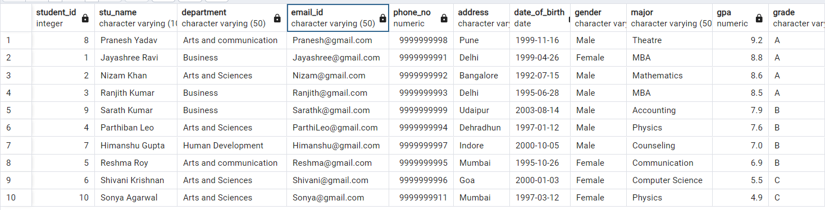

**4) Query for Male students**

Select * from Student_table

where Gender = 'Male';

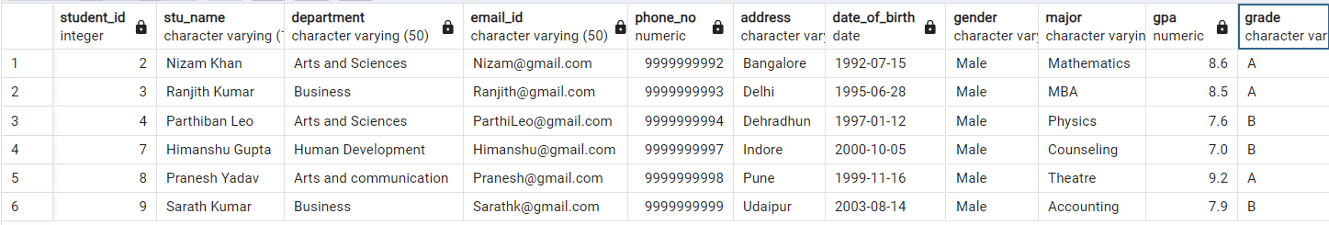

**5) Query for Students with GPA less than 5.0**

SELECT *

FROM Student_table

WHERE GPA <5.0;



**6) Update Student Email and Grade**

UPDATE Student_table

SET email_id = 'Sanyaa@gmail.com', Grade = 'D'

WHERE Student_id = '10';

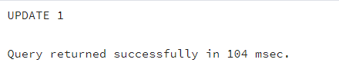

**7) Query for Students with Grade "B"**

SELECT Stu_name, date_part('year',age(Date_Of_Birth)) as Age

FROM Student_table

Where Grade = 'B';

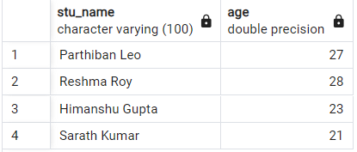

**8) Grouping and calculation**

SELECT Department, Gender, Avg(GPA)

FROM Student_table

GROUP BY 1,2;

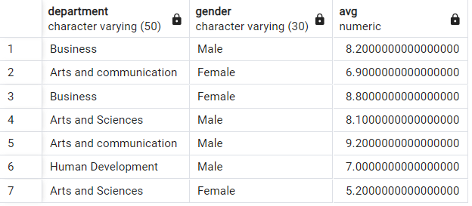

**9) Table Renaming**

ALTER TABLE Student_table

RENAME TO Student_info;

SELECT * FROM Student_info;

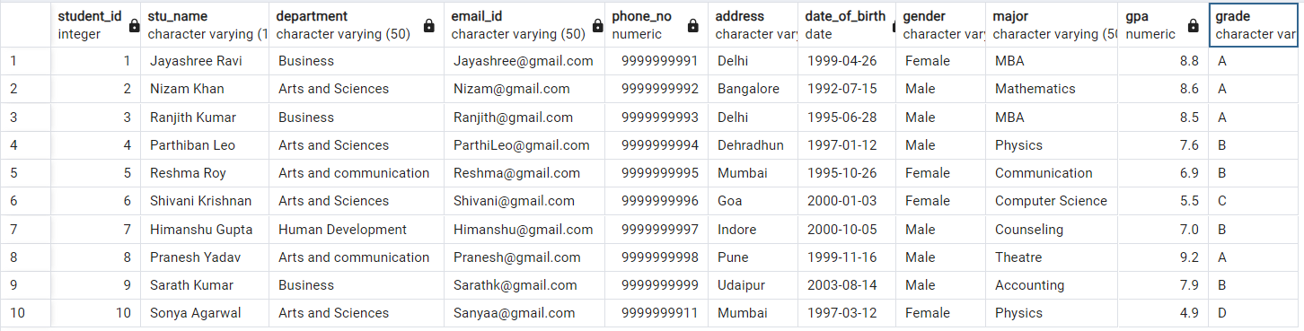

**10) Retrieve Student with Highest GPA**

SELECT Stu_name, GPA

FROM Student_info WHERE GPA = (Select Max(GPA) From Student_info);

